Review Section 4.3.2, 5.3.2, 5.3.3, 5.3.4 and 6.1 in Goldsman, D. & Goldsman, P. (2020). A First Course in Probability and Statistics. Lulu. [Download link](https://www.lulu.com/search?page=1&q=goldsman&pageSize=10&adult_audience_rating=00)

**Not all tables for these distributions are the same. Having an understanding of how probability, cumulative distribution functions, and inverse cumulative distribution functions works is more important than memorizing how to use these tables. If you have the fundamentals down, then you can use any table or software no matter how they have defined these concepts.**

**Be mindful when dealing with probability distributions. Different textbooks, online resources, and software tools may have slightly different ways of defining some distributions and may parameterize them differently as well. Always read the documentation!**

# Standard Normal Table

## Quantiles

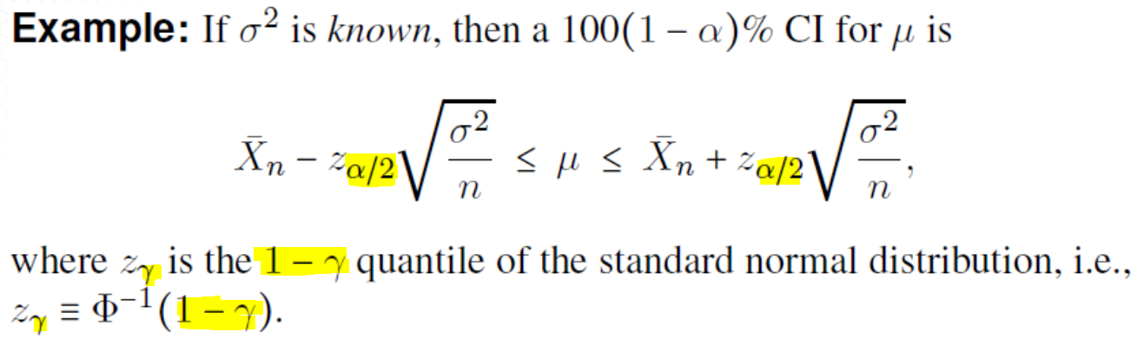

If we want to find a 95% confidence interval, this implies that [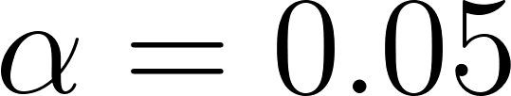](https://www.codecogs.com/eqnedit.php?latex=%5Calpha%3D0.05#0) and [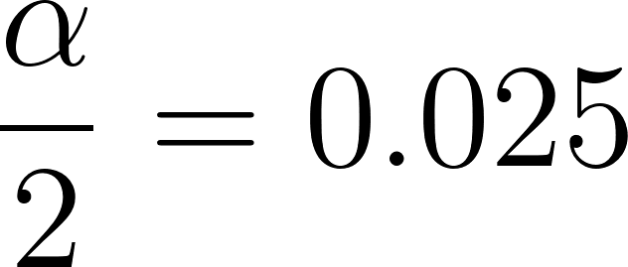](https://www.codecogs.com/eqnedit.php?latex=%5Cdfrac%7B%5Calpha%7D%7B2%7D%3D0.025#0).

In order to find the correct z-value, we need to be aware that by Dave’s definition and notation, this means we are looking for [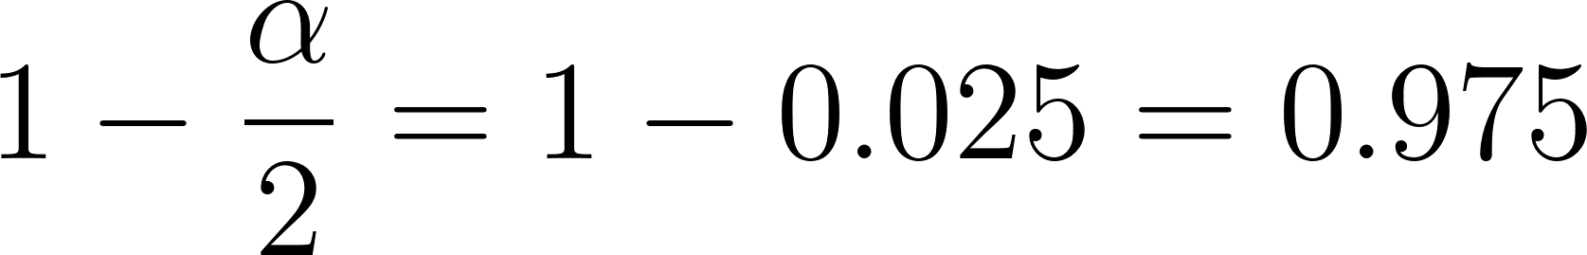](https://www.codecogs.com/eqnedit.php?latex=1-%5Cdfrac%7B%5Calpha%7D%7B2%7D%3D1-0.025%3D0.975#0)

When using the table, we will want to take the following steps:

1. Find an entry in the table that is close to [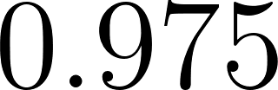](https://www.codecogs.com/eqnedit.php?latex=0.975#0).
2. Follow the row all the way to the left to obtain the z value to one decimal place.
3. Follow the column all the way up to obtain the z value’s second decimal place.

The result is a z value of 1.96.

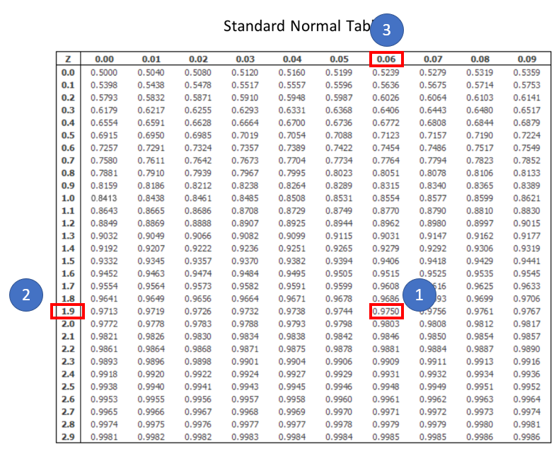

### Software

#### R

> qnorm(0.975)

[1] 1.959964

#### Python

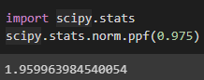

#### MATLAB

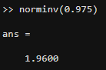

#### Excel

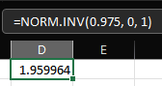

#### Texas Instruments Calculators

invNorm(0.975, 0, 1)

## Probabilities

The probabilities given in the table are for positive z values and are the areas/probabilities to the left of those z values.

For positive z values, you can use the table directly; to find [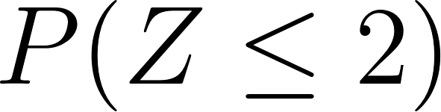](https://www.codecogs.com/eqnedit.php?latex=P(Z%20%5Cleq%202)#0):

1. Find the z value in the left column to one decimal place.
2. Find the z value’s second decimal place in the top row.
3. Find the intersection between the column and the row.

The value is 0.9772

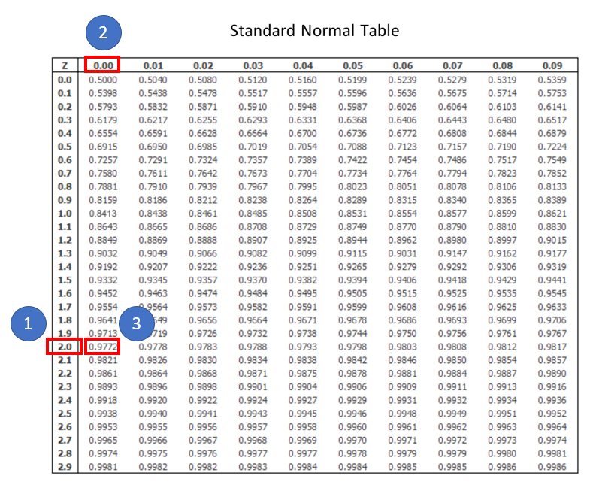

For negative z values, you can use the symmetry of the Normal distribution. [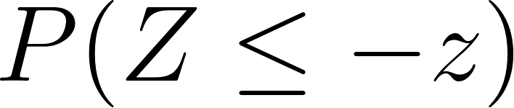](https://www.codecogs.com/eqnedit.php?latex=P(Z%20%5Cleq%20-z)#0) represents the area to the left of [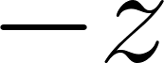](https://www.codecogs.com/eqnedit.php?latex=-z#0). The area to the right of the positive [](https://www.codecogs.com/eqnedit.php?latex=z#0) value will have the same value. So [](https://www.codecogs.com/eqnedit.php?latex=P(Z%20%5Cleq%20-z)%3DP(Z%20%3E%20z)%3D1-P(Z%20%5Cleq%20z)#0)

To find [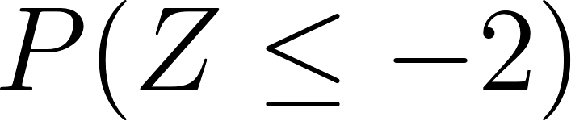](https://www.codecogs.com/eqnedit.php?latex=P(Z%20%5Cleq%20-2)#0), we use [](https://www.codecogs.com/eqnedit.php?latex=1-P(Z%20%5Cleq%202)%3D1-0.9772%3D0.0228#0)

To find the probability between [](https://www.codecogs.com/eqnedit.php?latex=-z#0) and [](https://www.codecogs.com/eqnedit.php?latex=z#0), [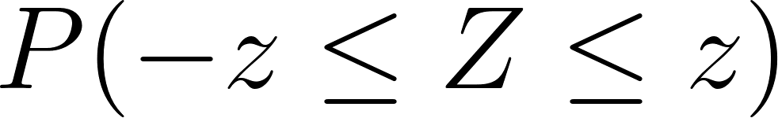](https://www.codecogs.com/eqnedit.php?latex=P(-z%20%5Cleq%20Z%20%5Cleq%20z)#0), you can think of this as finding [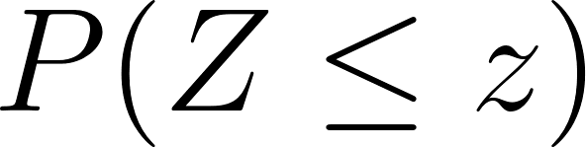](https://www.codecogs.com/eqnedit.php?latex=P(Z%20%5Cleq%20z)#0) and subtracting off the tail probability of [](https://www.codecogs.com/eqnedit.php?latex=P(Z%20%5Cleq%20-z)#0).

[](https://www.codecogs.com/eqnedit.php?latex=P(-z%20%5Cleq%20Z%20%5Cleq%20z)%3DP(Z%20%5Cleq%20z)%20-%20P(Z%20%5Cleq%20-z)#0)

From above, we saw that [](https://www.codecogs.com/eqnedit.php?latex=P(Z%20%5Cleq%20-z)%3D1-P(Z%20%5Cleq%20z)#0). Substituting this back into the expression above:

[](https://www.codecogs.com/eqnedit.php?latex=P(Z%5Cleq%20z)%20-%20(1%20-%20P(Z%5Cleq%20z))%3D2P(Z%5Cleq%20z)-1#0)

For [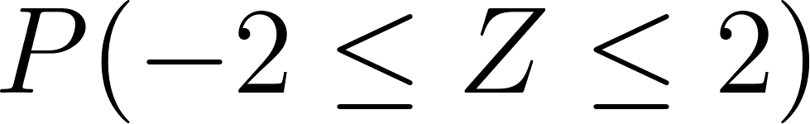](https://www.codecogs.com/eqnedit.php?latex=P(-2%20%5Cleq%20Z%20%5Cleq%202)#0) this is [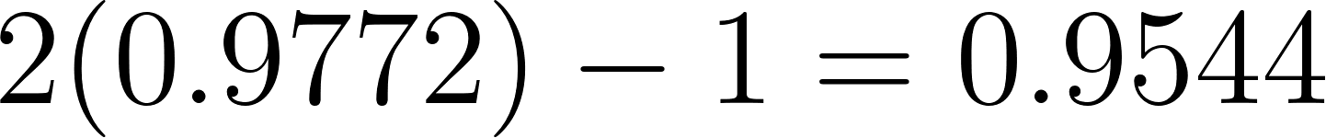](https://www.codecogs.com/eqnedit.php?latex=2(0.9772)%20-%201%3D0.9544#0)

It might also be worthwhile to review the [68–95–99.7](https://en.wikipedia.org/wiki/68%E2%80%9395%E2%80%9399.7_rule) rule.

For any other types of probabilities where you are finding between two values that are not the same, you may need to sketch a drawing with the area you are looking for to figure out what values to use.

The general way to do this for [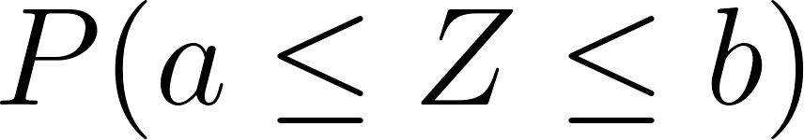](https://www.codecogs.com/eqnedit.php?latex=P(a%20%5Cleq%20Z%20%5Cleq%20b)#0) is to find [](https://www.codecogs.com/eqnedit.php?latex=%5CPhi(b)-%5CPhi(a)%3DP(Z%20%5Cleq%20b)%20-%20P(Z%20%5Cleq%20a)#0). You can think of this as subtracting off the area to the left of [](https://www.codecogs.com/eqnedit.php?latex=a#0) and leaving only the area between [](https://www.codecogs.com/eqnedit.php?latex=a#0) and [](https://www.codecogs.com/eqnedit.php?latex=b#0).

You can relate this back to integration. If we let [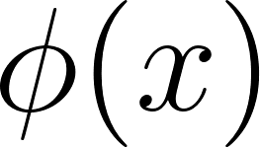](https://www.codecogs.com/eqnedit.php?latex=%5Cphi%20(x)#0) be the standard Normal PDF and [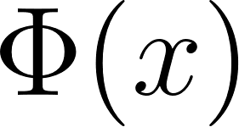](https://www.codecogs.com/eqnedit.php?latex=%5CPhi(x)#0) be the standard Normal CDF then when doing the integral from [](https://www.codecogs.com/eqnedit.php?latex=a#0) to [](https://www.codecogs.com/eqnedit.php?latex=b#0) over the PDF we would have:

[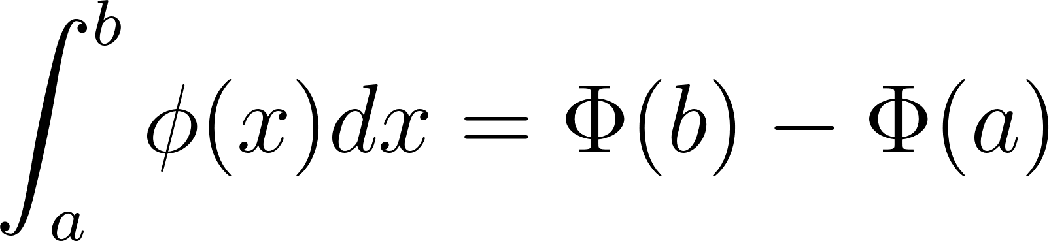](https://www.codecogs.com/eqnedit.php?latex=%5Cint_a%5Eb%20%5Cphi%20(x)dx%3D%5CPhi(b)-%5CPhi(a)#0)

### Software

#### R

> pnorm(2)

[1] 0.9772499

> 1 - pnorm(2)

[1] 0.02275013

> 2*pnorm(2) - 1

[1] 0.9544997

#### Python

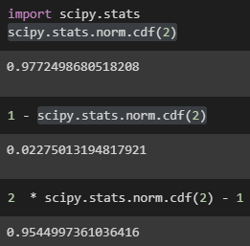

#### MATLAB

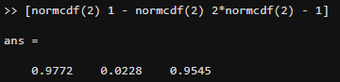

#### Excel

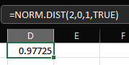

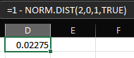

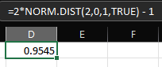

#### Texas Instruments Calculators

normCDF([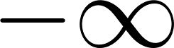](https://www.codecogs.com/eqnedit.php?latex=-%5Cinfty#0), 2, 0, 1)

normCDF(2, [](https://www.codecogs.com/eqnedit.php?latex=%5Cinfty#0), 0 , 1)

normCDF(-2, 2, 0, 1)

# Student’s t Distribution Table

The t-distribution is different from the standard Normal distribution table. First it contains the degrees of freedom parameter for the t-distribution, and the probabilities are in the column headings with the t-values in the table itself (this is the opposite of how the standard Normal table is presented).

## Quantiles

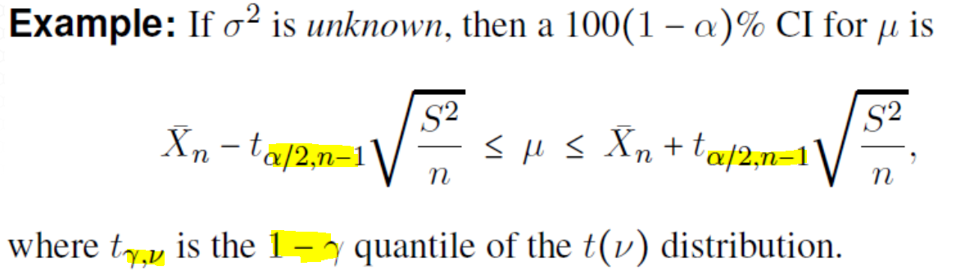

The same logic applies here to compute the quantiles as it did for the Normal distribution; the difference is that the t distribution has an additional parameter for degrees of freedom.

If we want to find a 95% confidence interval, this implies that [](https://www.codecogs.com/eqnedit.php?latex=%5Calpha%3D0.05#0) and [](https://www.codecogs.com/eqnedit.php?latex=%5Cdfrac%7B%5Calpha%7D%7B2%7D%3D0.025#0).

We will assume we are using a t distribution with 19 degrees of freedom. Since this table gives probabilities above the tabulated values, we can use the value of [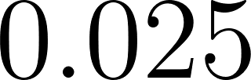](https://www.codecogs.com/eqnedit.php?latex=0.025#0) directly.

1. Find the row for the corresponding number of degrees of freedom.
2. Find the column with the probability desired.
3. Find the intersection between the column and the row.

The value is 2.093.

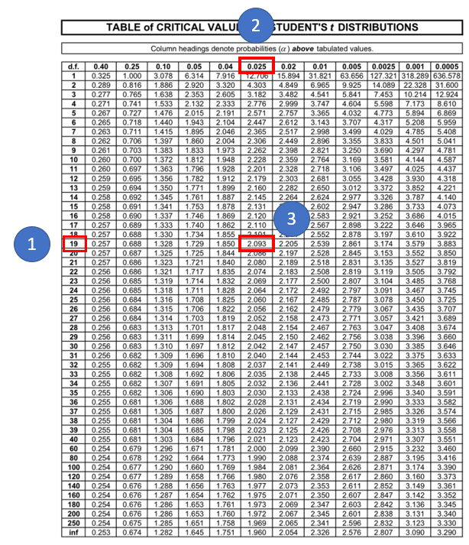

### Software

#### R

> qt(0.025, 19, lower.tail = FALSE)

[1] 2.093024

#### Python

Note that for Python you need to use [](https://www.codecogs.com/eqnedit.php?latex=1-0.025%3D0.975#0) as the function always returns based on the lower tail.

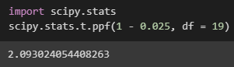

#### MATLAB

MATLAB also returns the lower tail.

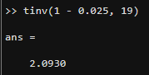

#### Excel

Excel also returns the lower tail.

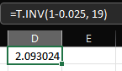

#### Texas Instruments Calculators

invt(0.975, 19)

## Probabilities

It’s not common (at least in ISyE 6644) to ask for probabilities for the t distribution. The table can be used, but it’s not a great tool for the job. I do not believe you will be asked to do this in this course, so I will skip the explanation of how to use the table

### Software

#### R

> pt(2.093, 19)

[1] 0.9749988

> 1 - pt(2.093, 19)

[1] 0.02500119

> 2*pt(2.093, 19) - 1

[1] 0.9499976

#### Python

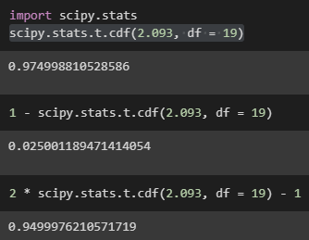

#### MATLAB

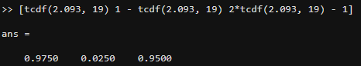

#### Excel

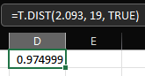

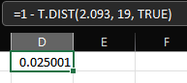

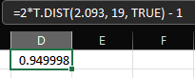

#### Texas Instruments Calculators

tCDF([](https://www.codecogs.com/eqnedit.php?latex=-%5Cinfty#0), 2.093, 0, 1)

tCDF(2.093, [](https://www.codecogs.com/eqnedit.php?latex=%5Cinfty#0), 0 , 1)

tCDF(-2.093, 2.093, 0, 1)

# Chi-squared Distribution Table

The [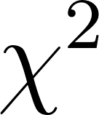](https://www.codecogs.com/eqnedit.php?latex=%5Cchi%5E2#0) table is similar to the t distribution table with degrees of freedom to the left and probabilities as the column headings. The probabilities as given are to the right of the indicated critical values.

## Quantiles

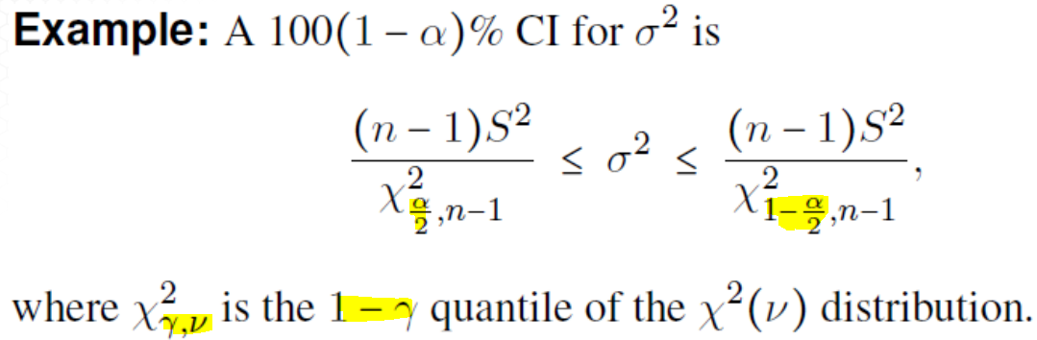

Notice the difference with the use of [](https://www.codecogs.com/eqnedit.php?latex=%5Cdfrac%7B%5Calpha%7D%7B2%7D#0) for the left side and [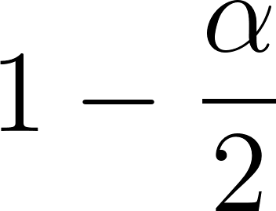](https://www.codecogs.com/eqnedit.php?latex=1-%5Cdfrac%7B%5Calpha%7D%7B2%7D#0). This is because the [](https://www.codecogs.com/eqnedit.php?latex=%5Cchi%5E2#0) distribution is not symmetric and its [support](https://en.wikipedia.org/wiki/Support_(mathematics)) is only positive values (since the distribution results from squaring Normal random variables, it can only take on positive values).

We will assume we are using a [](https://www.codecogs.com/eqnedit.php?latex=%5Cchi%5E2#0) distribution with 4 degrees of freedom. Since this table gives probabilities above the tabulated values, we can use the value of [](https://www.codecogs.com/eqnedit.php?latex=0.025#0) directly. We typically in this course will use critical values from this table for hypothesis testing purposes, so if the test statistic is less than the critical value, we will fail to reject the null hypothesis; otherwise, the test statistic is above the critical value and we reject the null hypothesis. This means we are always interested in the upper tail probability here and that is why this table is designed this way.

For a hypothesis test with an [](https://www.codecogs.com/eqnedit.php?latex=%5Calpha%3D0.05#0) we can read this from the table by doing the following:

1. Find the row for the corresponding number of degrees of freedom.
2. Find the column with the probability desired.
3. Find the intersection between the column and the row.

The value is 9.49.

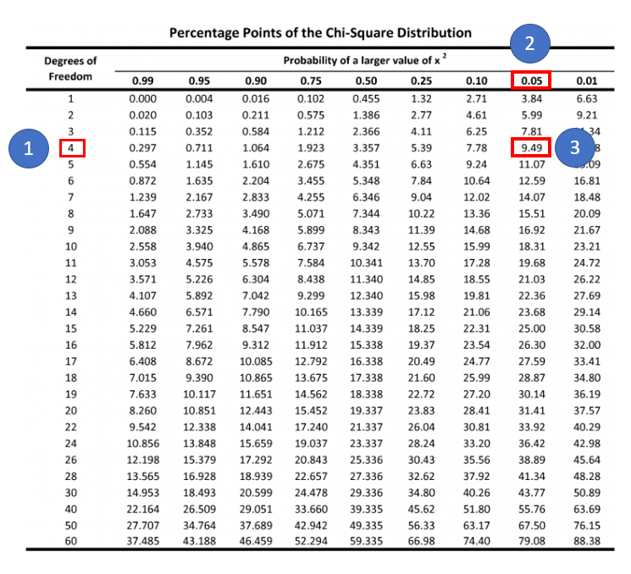

### Software

#### R

> qchisq(0.05, 4, lower.tail = FALSE)

[1] 9.487729

#### Python

For Python you will need to use 1 minus the value from the table since Python always returns lower tailed. Notice when using the wrong value, it actually matches the value for 0.95 from the table above.

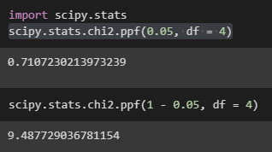

#### MATLAB

MATLAB needs to be treated the same as Python.

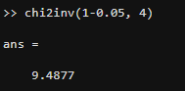

#### Excel

Excel also needs to be treated the same way.

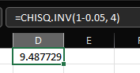

#### Texas Instruments Calculators

inv[](https://www.codecogs.com/eqnedit.php?latex=%5Cchi%5E2#0)(0.95, 4)

## Probabilities

It’s not common (at least in ISyE 6644) to ask for probabilities for the [](https://www.codecogs.com/eqnedit.php?latex=%5Cchi%5E2#0) distribution. The table can be used, but it’s not a great tool for the job. I do not believe you will be asked to do this in this course, so I will skip the explanation of how to use the table. Since the distribution is not symmetric, the same “tricks” that worked for the standard Normal and t distribution don’t work.

### Software

#### R

> # P(X <= 9.49)

> pchisq(9.49, 4)

[1] 0.9500469

> # P(X > 9.49)

> pchisq(9.49, 4, lower.tail = FALSE)

[1] 0.04995313

> # P(5 <= X <= 9.49)

> pchisq(9.49, 4) - pchisq(5, 4)

[1] 0.2373444

#### Python

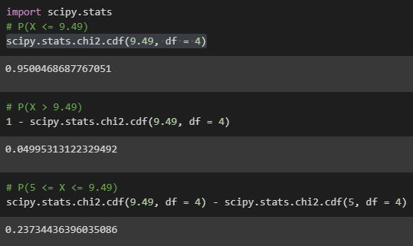

#### MATLAB

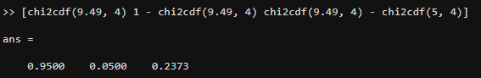

#### Excel

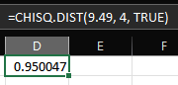

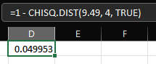

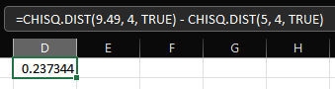

#### Texas Instruments Calculators

[](https://www.codecogs.com/eqnedit.php?latex=%5Cchi%5E2#0)CDF(0, 9.49, 4)

[](https://www.codecogs.com/eqnedit.php?latex=%5Cchi%5E2#0)CDF(9.49, [](https://www.codecogs.com/eqnedit.php?latex=%5Cinfty#0), 4)

[](https://www.codecogs.com/eqnedit.php?latex=%5Cchi%5E2#0)CDF(5, 9.49, 4)